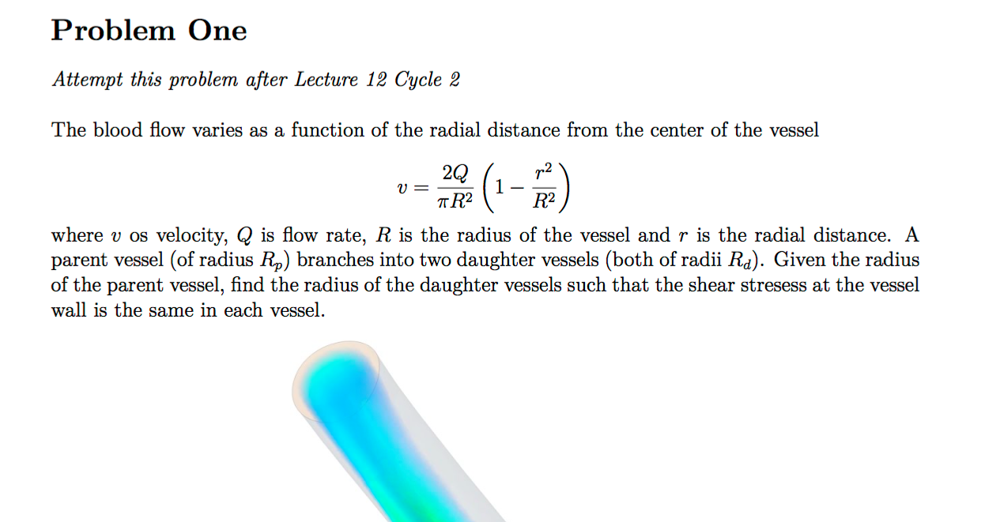

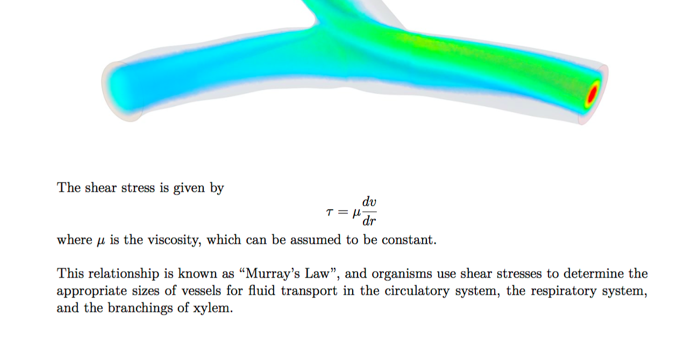
Given the radius of the parent vessel is 0.0052, find the radius of the daughter vessels such that the shear stresses at the vessel wall is the same in each vessel. See pdf for more details.

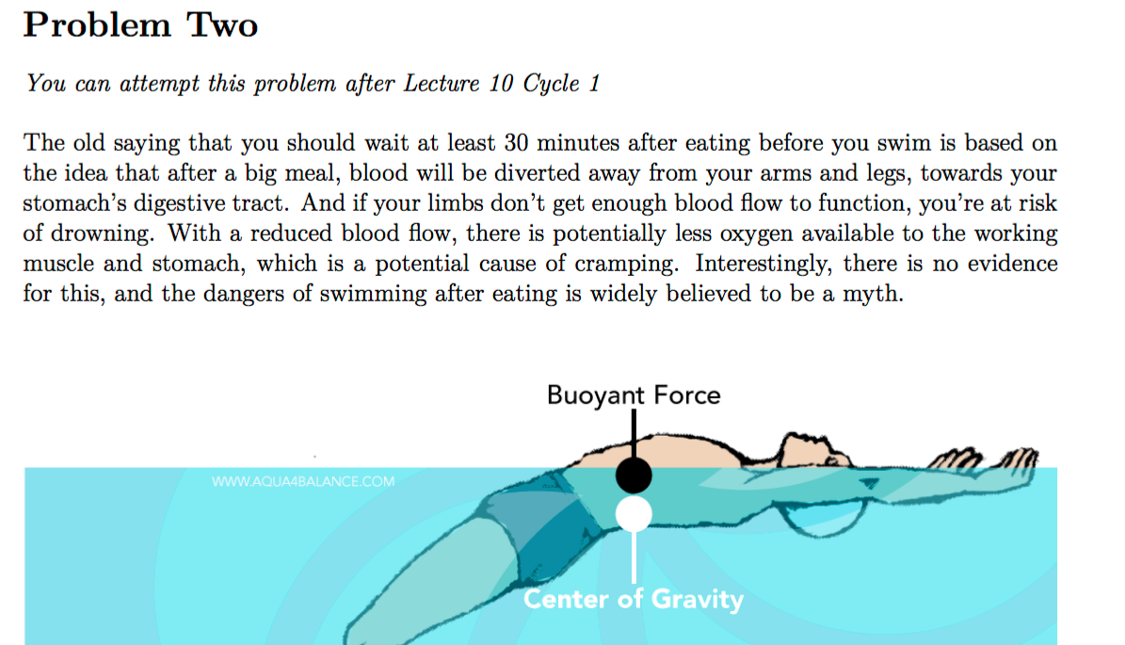

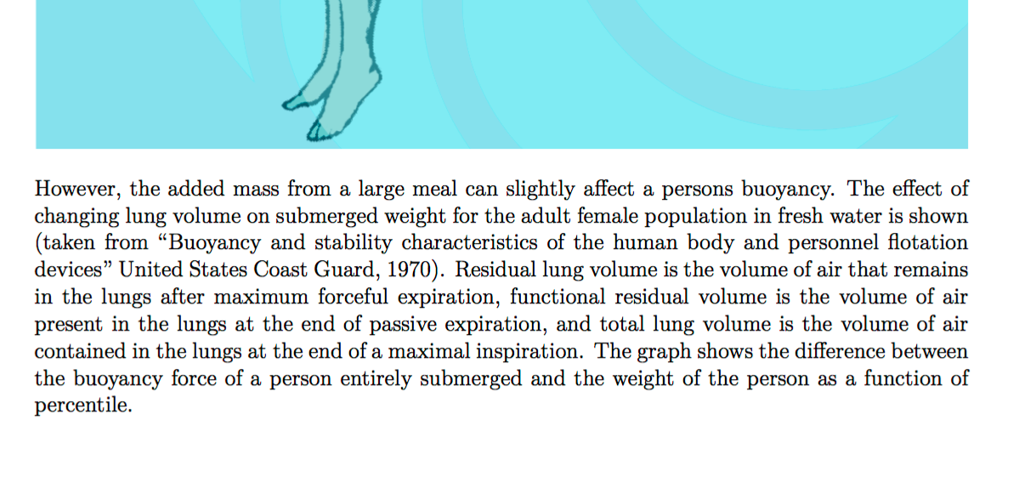
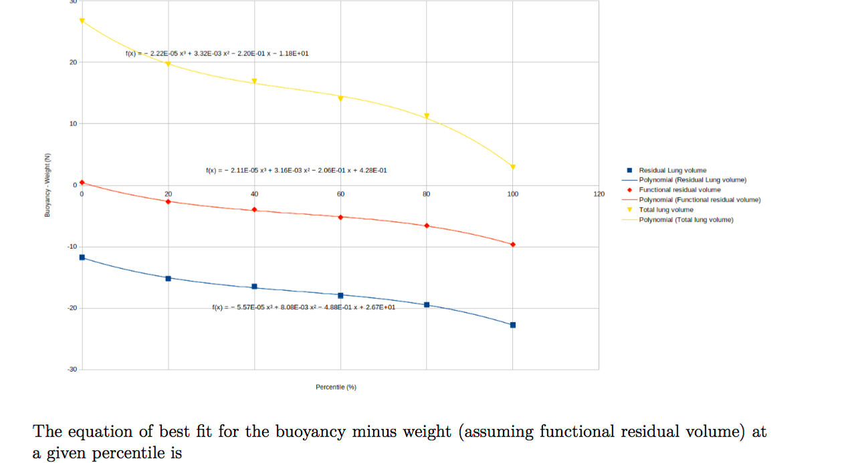
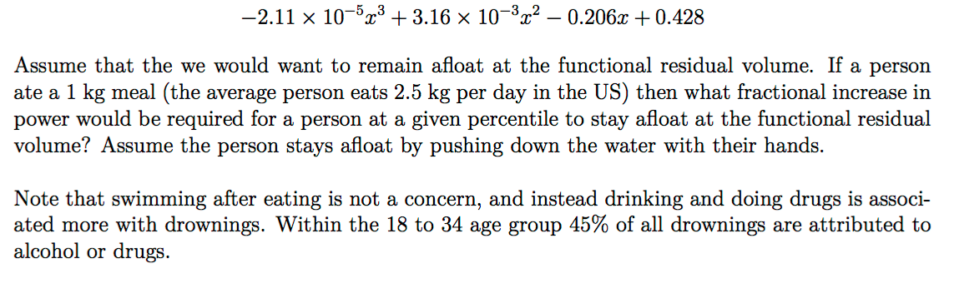
If a person ate a 1 kg meal then what fractional increase in power would be required for a person at a given percentile of 10.9 percent to stay afloat at the functional residual volume? See pdf for more details.

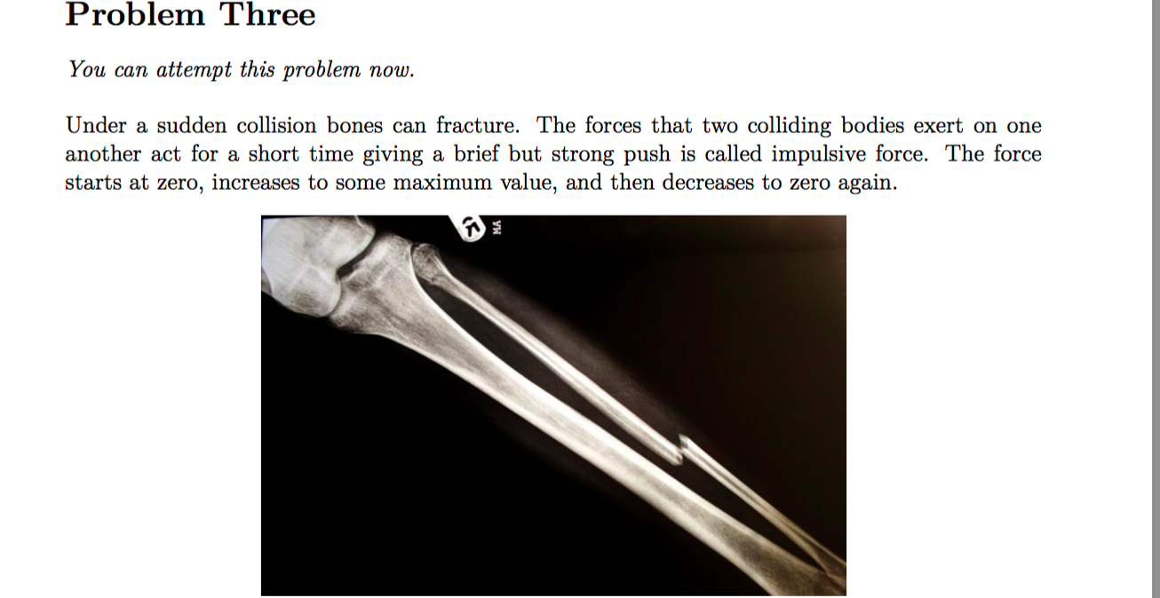

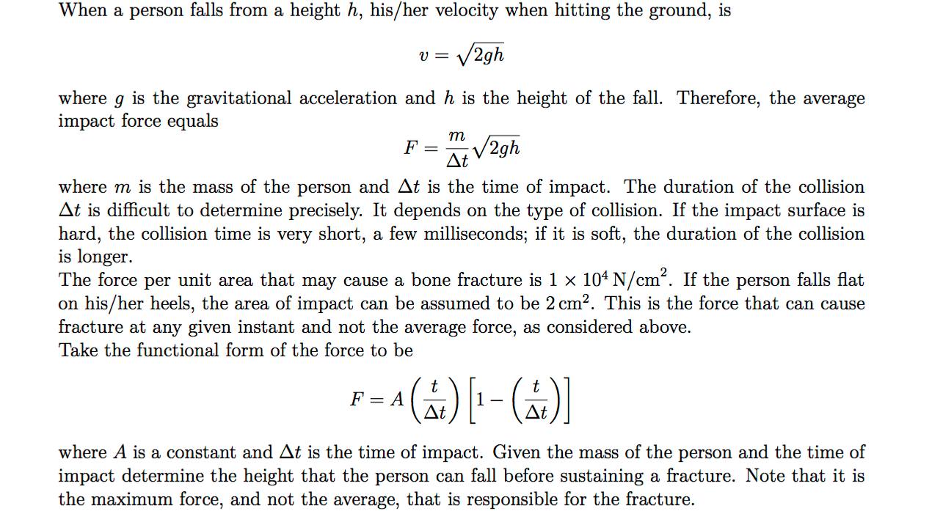
iven the mass of the person to be 65.4 and the time of impact to be 0.00935, determine the height that the person can fall before sustaining a fracture.

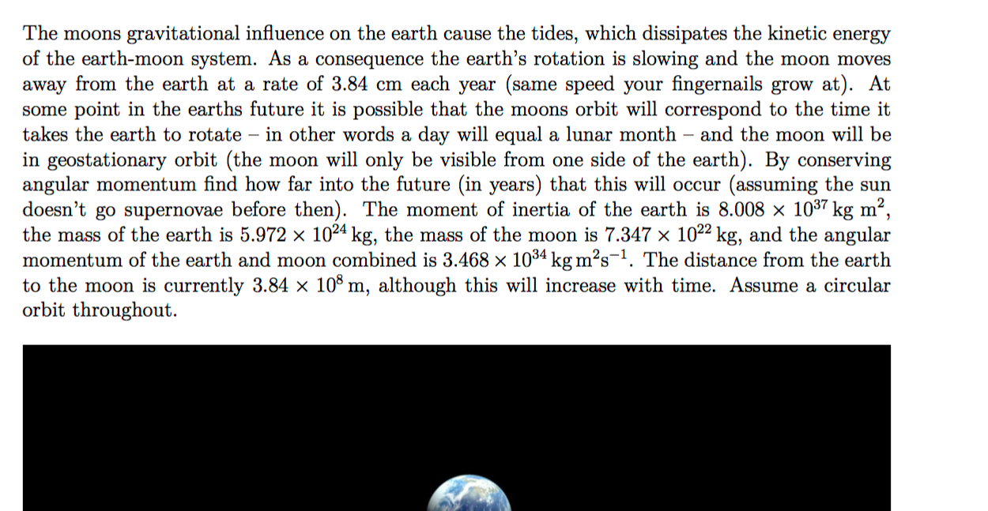

At some point in the earths future it is possible that the moons orbit will correspond to the time it
takes the earth to rotate and the moon will be in geostationary orbit. By conserving angular momentum find how far into the future (in years) that this will occur (assuming the sun
doesn’t go supernovae before then).

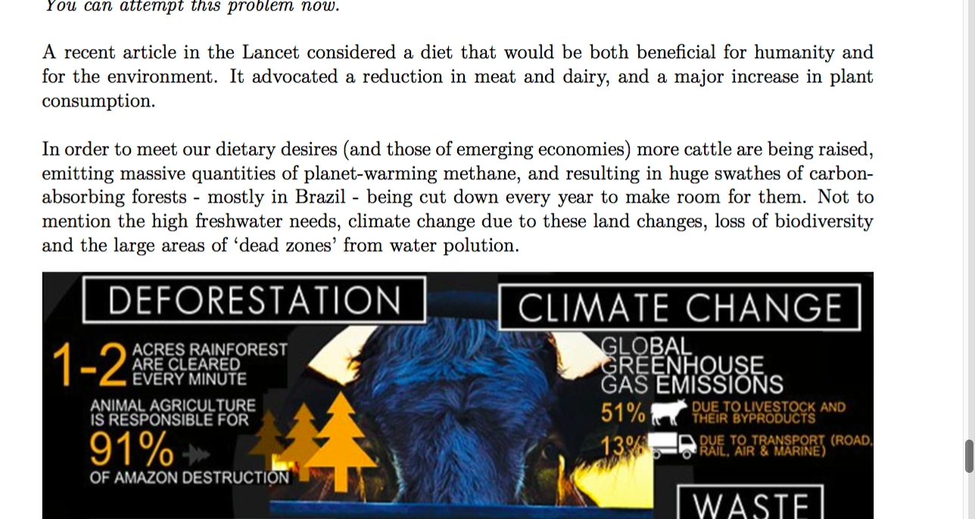

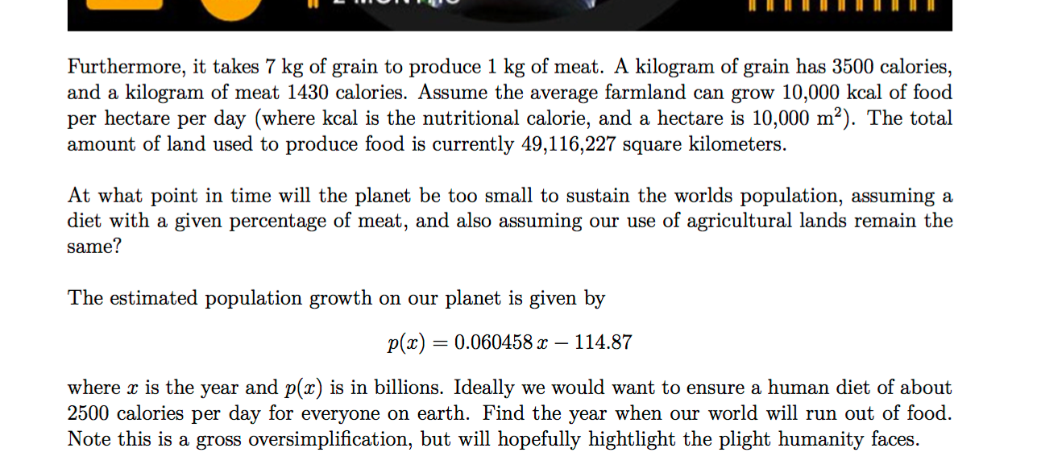
At what point in time will the planet be too small to sustain the worlds population, assuming a diet with a percentage of meat of 15.4 percent? See pdf for more information.

